The Small Footprint CIM Broker Daemon (SFCBD) is not Running.

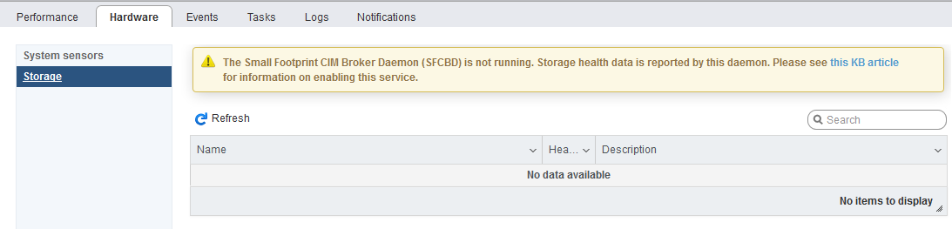

Issue:
-Service CIM Agent stopped
-Unable to start Service from webconsole

Problem Solving
- Login to vspheree console (cli)
- Check sfcbd service
/etc/init.d/sfcbd-watchdog status

sfcbd is not running

- Check status cim agent
esxcli system wbem get

Authorization Model: password
Enabled: false
Loglevel: warning
Port: 5989
WSManagement Service: true

- start the sfcbd-watchdog service manually via the command
esxcli system wbem set --enable true

- Check cim agent status
esxcli system wbem get

Authorization Model: password
Enabled: false
Loglevel: warning
Port: 5989
WSManagement Service: true

